Electronic Filter Wheel

Remote Operations Guide
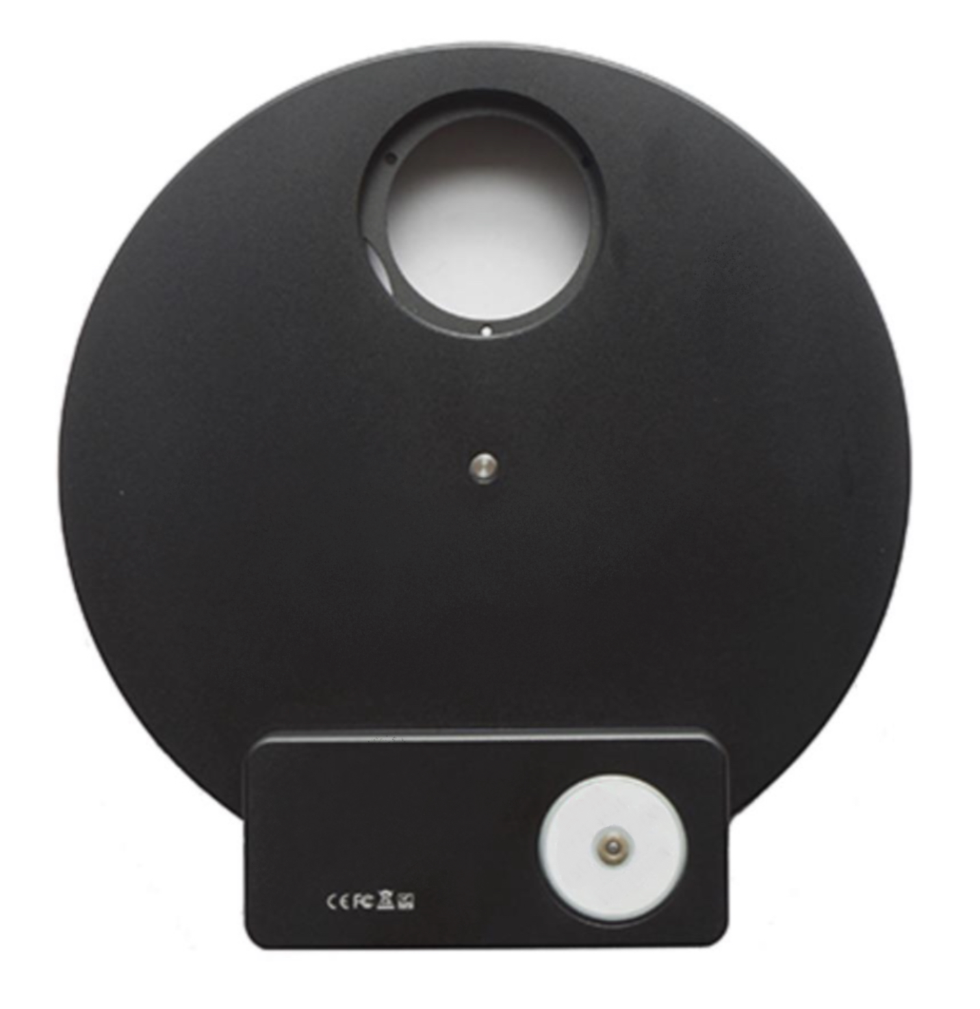

OPTECALI-ZEPTO, Inc.

www.optecali.com

email: info@optecali.com

Table of Contents

Introduction 3
Installation of Filters 3
Connecting EFW to Camera 4
Driver Installation 5
Troubleshooting Common Problems 5
Introduction - Software 5
Definition of enum-type and struct 6
Typedef enum_EFW_ERROR_CODE 6
Typedef enum_EFW_INFO 6
Function declaration 7
EFW Get Num 7
EFW Get ID 7
EFW Get Property 7
EFW Open 8
EFW Get Position 8
EFW Set Position 9
EFW Set Direction 9
EFW Get Direction 10
EFW Close 10
EFW Get Product IDs 10
EFW Calibrate 11
Suggested Call Sequence 11
Contact Information 12

Introduction

Thank you for purchasing the Electronic Filter Wheel (EFW). Please read this Quick Start Guide for further information and if you have any additional questions, please contact us at info@optecali.com

Electronic filter wheels (EFW) are filter wheels used with mono cameras for astrophotography. Optecali offers several configurations depending on the filter size and number of filters used. A EFW simply requires a USB connection for use and power. You may control it from a variety of hosts such as Windows, Arm Linux, Android and iOS system.

Four configurations of the EFW are currently available:
  - 5 Position: Accepts 1”
  - 5 Position: Accepts 2

Installation of Filters

1′′ & 2" size mounted filters: (Please note that filters must be less than 7mm in thickness (not including the threads) and threads must be less than 3mm in thickness.)
  - Remove the screws securing the back cover and remove the back cover
  - Set the wheel on a flat surface with the face down
  - Screw the filters into the threaded wheel positions
  - Replace the back cover and tighten the screws
The following lens adapter is necessary for usage of the filter wheel
  - SM1 female to M28.5x0.6 male thread adapter
  - For usage attach the threaded side of the lens adapter to the filter wheel
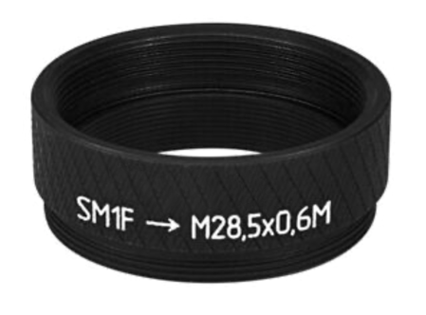

Connecting EFW to Camera

You can connect your camera to the EFW with a 1" nose piece or simply thread it directly to the M42 interface. Please pay attention to the direction of EFW when you connect to the camera to ensure that the filters are as close to the sensor as possible to minimize the chance of vignetting.

Driver Installation

The EFW are designed as a USB HID device (like a keyboard or mouse) so you only need to install the ‘Filter Wheel Utility’ driver for use.

Download and install the Filter wheel Utility that is included with your EFW.
-Important: Make sure you also install ‘My Installer’ set up application first.
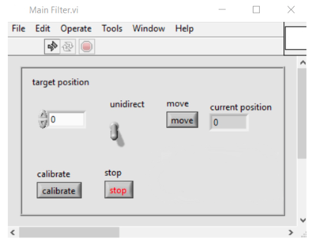

Troubleshooting Common Problems
  - My EFW tries to move but gets stuck and cannot arrive at the right position.
    - Filter is too thick: Filters (not including the threads) must be less than 7mm in thickness and threads must be less than 3mm in thickness.
    - The M2 screw used to secure the filter is too long and causes the wheel to jam.
    - The M42 thread of the scope or the camera is too long and protrudes into the filter wheel, hitting the filter or wheel, causing it to jam.
2. My EFW spins but never stops or stops at the wrong position.
The EFW uses an infrared sensor to check wheel position. If the sensor malfunctions, you can usually resolve by recalibrating the EFW in the driver. Simpl
y click "calibrate" in the driver interface. It can take up to 60 seconds to perform this action.

If this does not resolve your problem, contact us at: info@optecali.com

Introduction - Software
This SDK is used to operate EFW serial filter wheel, can be used by C, C++, C# and other develop tools, is suit for Windows, Linux, OSX operating system of x86 and x64.
Header file: EFW_filter.h
Under Windows the import library and dynamic library: EFW_filter.lib、EFW_filter.dll
Under Linux the dynamic library and static library: EFW_filter.so、EFW_filter.a
Under OSX the dynamic library and static library: EFW_filter.dylib、EFW_filter.a
Installation method:
Under Windows, extract the downloaded zip file to any directory, and
add DLL's path to system environment variables, sometimes logout and re-login is
required.

Definition of enum-type and struct

Typedef enum_EFW_ERROR_CODE

{EFW_SUCCESS = 0,
EFW_ERROR_INVALID_INDEX,
EFW_ERROR_INVALID_ID,
EFW_ERROR_INVALID_VALUE,
EFW_ERROR_CLOSED, //not opened
EFW_ERROR_REMOVED, //failed to find the filter wheel, maybe the filter wheel has been
removed
EFW_ERROR_MOVING,//filter wheel is moving
EFW_ERROR_GENERAL_ERROR,//other error
EFW_ERROR_CLOSED,
EFW_ERROR_END = -1
}EFW_ERROR_CODE;
Returned error code

Typedef enum_EFW_INFO
{int ID;
char Name[64];
int slotNum;
} EFW_INFO;
Filter wheel information

Function declaration

EFW Get Num

Syntax： int EFWGetNum()
Descriptions :
This should be the first API to be called, get number of connected EFW filter wheel, call
this API to refresh device list if EFW is connected or disconnected.
Return: number of connected EFW filter wheel. 1 means 1 filter wheel is connected.

EFW Get ID
Syntax: EFW_ERROR_CODE EFWGetID(int index, int* ID)
Descriptions :
Get ID of filter wheel
Paras:
int index: the index of filter wheel, from 0 to N - 1, N is returned by EFWGetNum()
int* ID: pointer to ID. if the filter wheel is not opened, the ID is negative, otherwise the ID
is a unique
integer between 0 to EFW_ID_MAX - 1, after opened, all the operation is base on this
ID, the ID will
not change before the filter wheel is closed.
Return:
EFW_ERROR_INVALID_INDEX: index value is invalid
EFW_SUCCESS: operation succeeds

EFW Get Property

Syntax: EFW_ERROR_CODE EFWGetProperty(int ID, EFW_INFO *pInfo)
Descriptions :
Get property of filter wheel.
Paras:
int ID: the ID of filter wheel
EFW_INFO *pInfo: pointer to structure containing the property of EFW
Return:
EFW_ERROR_INVALID_ID: invalid ID value
EFW_ERROR_CLOSED: the filter wheel is closed
EFW_ERROR_MOVING: slot number detection is in progress, generally this error will
happen soon after filter wheel is connected.
EFW_SUCCESS: operation succeeds

EFW Open

Syntax: EFW_ERROR_CODE EFWOpen(int ID)
Descriptions :
Open filter wheel
Paras:
int ID: the ID of filter wheel
Return:
EFW_ERROR_INVALID_ID: invalid ID value
EFW_ERROR_GENERAL_ERROR: number of opened filter wheel reaches the maximum
value.
EFW_ERROR_REMOVED: the filter wheel is removed.
EFW_SUCCESS: operation succeeds

EFW Get Position

Syntax: EFW_ERROR_CODE EFWGetPosition(int ID, int *pPosition)
Descriptions :
Get position of slot
Paras:
int ID: the ID of filter wheel
int *pPosition: pointer to slot position, this value is between 0 to M - 1, M is slot number
this value is -1 if filter wheel is moving
Return:
EFW_ERROR_INVALID_ID: invalid ID value
EFW_ERROR_CLOSED: the filter wheel is closed
EFW_SUCCESS: operation succeeds
EFW_ERROR_ERROR_STATE: filter wheel is in error state.

EFW Set Position

Syntax: EFW_ERROR_CODE EFWSetPosition(int ID, int Position)
Descriptions :
Set position of slot
Paras:
int ID: the ID of filter wheel
int Position: slot position, this value is between 0 to M - 1, M is slot number
Return:
EFW_ERROR_INVALID_ID: invalid ID value
EFW_ERROR_CLOSED: the filter wheel is closed
EFW_SUCCESS: operation succeeds
EFW_ERROR_INVALID_VALUE: Position value is invalid
EFW_ERROR_MOVING: filter wheel is moving, should wait until idle
EFW_ERROR_ERROR_STATE: filter wheel is in error state

EFW Set Direction

Syntax: EFW_ERROR_CODE EFWSetDirection(int ID, bool bUnidirectional)
Descriptions :
Set unidirection of filter wheel
Paras:
int ID: the ID of filter wheel
bool bUnidirectional: if set as true, the filter wheel will rotate along one direction
Return:
EFW_ERROR_INVALID_ID: invalid ID value
EFW_ERROR_CLOSED: the filter wheel is closed
EFW_SUCCESS: operation succeeds

EFW Get Direction

Syntax: EFW_ERROR_CODE EFWGetDirection(int ID, bool *bUnidirectional)
Descriptions :
Get unidirection of filter wheel
Paras:
int ID: the ID of filter wheel
bool *bUnidirectional: pointer to unidirection value .
Return:
EFW_ERROR_INVALID_ID: invalid ID value
EFW_ERROR_CLOSED: the filter wheel is closed
EFW_SUCCESS: operation succeeds

EFW Close

Syntax: EFW_ERROR_CODE EFWClose(int ID)
Descriptions :
Close filter wheel
Paras:
int ID: the ID of filter wheel
Return:
EFW_ERROR_INVALID_ID: invalid ID value
EFW_SUCCESS: operation succeeds

EFW Get Product IDs

Syntax: int EFWGetProductIDs(int* pPIDs)
Descriptions :
get the product ID of each wheel, at first set pPIDs as 0 and get length and then malloc a buffer to load
the PIDs
Paras:
int* pPIDs: pointer to array of PIDs
Return: length of the array.

EFW Calibrate

Syntax: EFW_ERROR_CODE EFWCalibrate(int ID)
Descriptions :
calibrate filter wheel
Paras:
int ID: the ID of filter wheel
Return:
EFW_ERROR_INVALID_ID: invalid ID value
EFW_ERROR_CLOSED: not opened
EFW_SUCCESS: operation succeeds
EFW_ERROR_MOVING: filter wheel is moving, should wait until idle
EFW_ERROR_ERROR_STATE: filter wheel is in error state
EFW_ERROR_REMOVED: filter wheel is removed

Suggested Call Sequence

Get count of connected filter wheels--> EFWGetNum
Get filter wheels' ID-> EFWGetID
Get filter wheels' name--> EFWGetProperty
Open filter wheel --> EFWOpen（Notes： this SDK can operate multiple filter wheels，distinguish by
each filter wheel's ID）
Rotate--> EFWSetPosition
Close filter wheel-->EFWClose

Contact Information

Customer and Technical Support
OPTECALI-ZEPTO
Email: info@optecali.com
Website: www.optecali.com

